Aerospace Industry Network
Louis Chenevert became 1st member of my private community The Hermitage Club.(*HC) At the time, he was Chairman & CEO of UTC now RTX. He brought up all of his executives and encouraged them to join which they did. His literal best friend is Jimmy Jacobs, Vice-Chairman of NetJets who also joined. Jimmy lives in Avon, CT, consults for NetJets, and consults for eVTOL manufacturer today. At the time, UTC also owned Associated Aircraft Group and introduced me to CEO Scott Ashton who flew Sikorsky’s into my club owned Deerfield Valley Airport . Alain Bellmare, President & CEO of UTC Propulsion & Aerospace joined and is now International President at Delta after CEO stint at Bombardier. Matt Bromberg, President Pratt & Whitney Aftermarket joined and is now CEO of CAE the leading eVTOL & Aircraft flight simulator training in the world. Charlie Gill, UTC EVP & General Counsel joined and is now a consultant. David Gitlin, President UTC Aerospace Systems joined, became Collins Aerospace CEO and is now Chairman CEO at Carrier. Jimmy Jacobs brought up partner Kenny Dichter, former CEO of Marquis Jet Card and Founder of Wheels Up which became a member.
I have spent a lot of recreational and social time with these people for a long time and continue to stay engaged. Their networks are deep- all remain actively engaged in industry with confidentiality and discretion. I’m connected to all on LinkedIn. Two of them had boys that went to Kingswood Oxford with my son.
As they are subject to and maintain confidentiality - I have asked hypothetical questions such as; “what do you think your contact would say presented with this value proposition, etc.”? My intelligence has been gathered by working indirectly through these contacts to decision makers and my anonymity has been preserved which is key to my strategy.
The following is a picture of Louis Chenevert from 2013 Annual Report: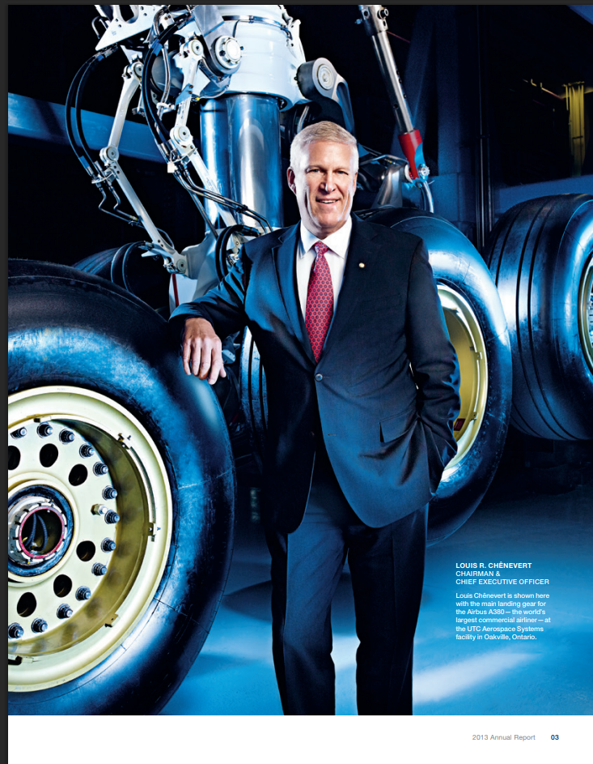

UTC Global Leadership from the 2013 Annual Report with the contacts above before they went to new companies:
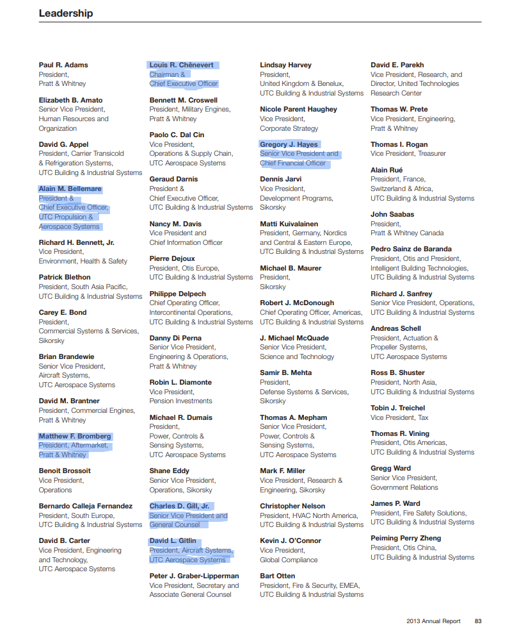
LinkedIn Profiles:
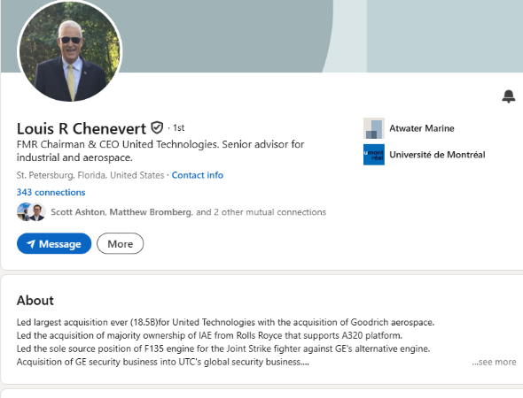
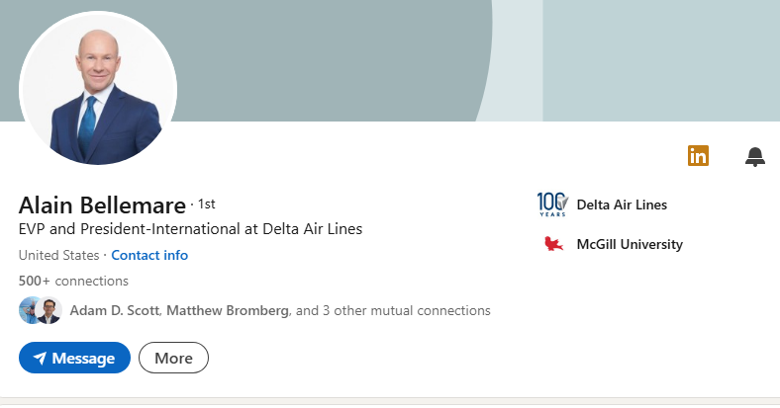
Our son’s went to Kingswood Oxford together.
Alain took helm as CEO of Bombardier at difficult time-now President International at Delta
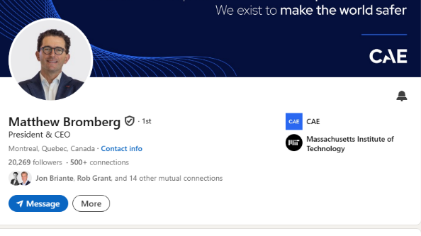
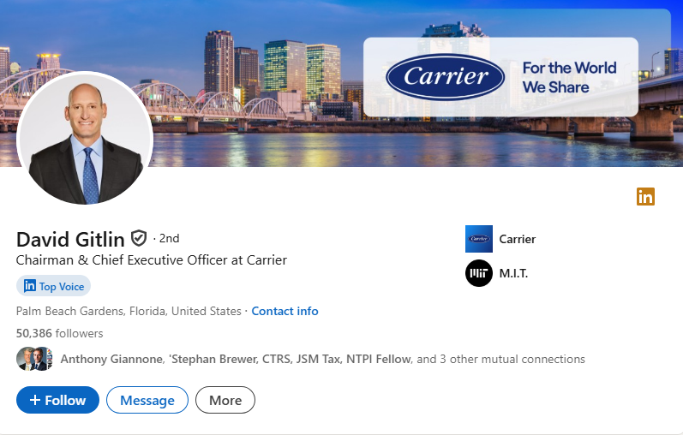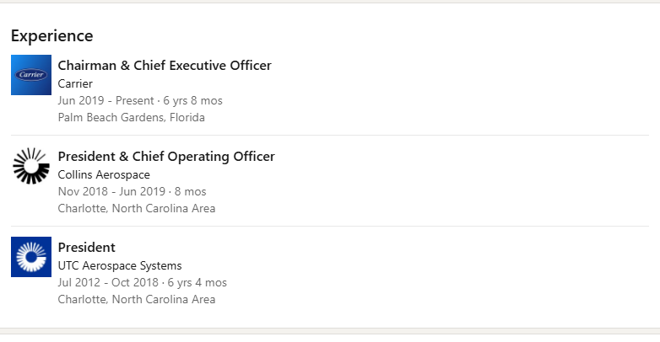
Responsible to integrate Louis Chenevert’s biggest deal $18B Goodrich Aerospace renamed UTC Aerospace Systems. Our sons went to Kingswood Oxford together.
-------------------------------------------------------------------------------------------------------------
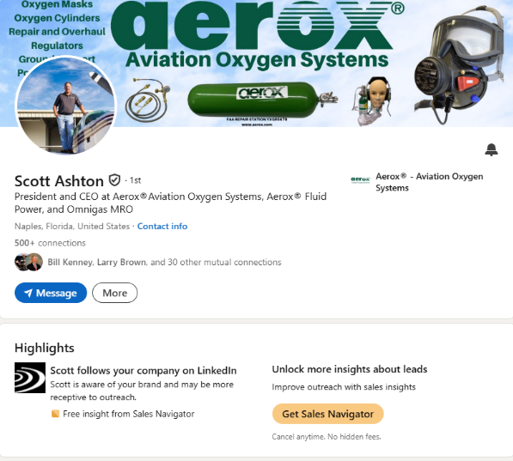
Scott was CEO Associated Aircraft Group (AAG), which was a subsidiary of Sikorsky Aircraft (a UTC company), was sold to OneSky Flight on February 4, 2021
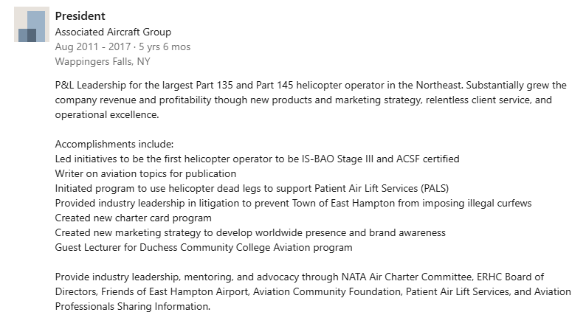
------------------------------------------------------------------------------------------------------------------

Jim Jacobs, Co-Founder, Vice Chairman. NetJets (*HC)
The primary lieutenant to founder Richard Santulli Known for his role in the company's growth, Jacobs was instrumental in launching the Marquis Jet card program, bridging the gap between fractional ownership and new customers and was considered the "number two" to CEO Richard Santulli. Marquis Jet Creation. Jacobs was pivotal in connecting Richard Santulli with the founders of Marquis Jet, which revolutionized the industry with the "jet card" concept. Following the 1998 acquisition of NetJets by Berkshire Hathaway, Jacobs continued to work closely with top management before moving into an advisory role during a transition period around 2009-2010. He was recognized as an expert in aviation, having helped navigate the company during periods of rapid growth and, later, financial challenges, as described in The New York Times and Aviation International News. Jacobs remained affiliated with the company through its expansion under Berkshire Hathaway.
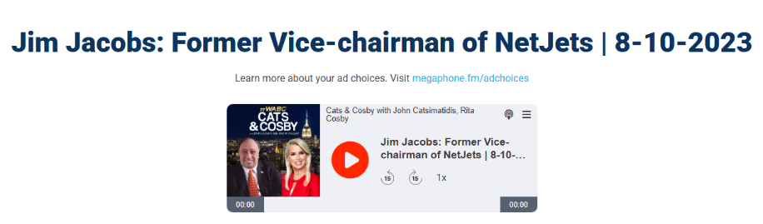
------------------------------------------------------------------------------------------------------------------------------

Kenny Dichter Founder, CEO Wheels Up (*HC)
A membership-based, "on-demand" private aviation company designed to democratize private travel through a, lower-cost model using Beechcraft King Air 350i turboprops. Following his success with Marquis Jet, Dichter expanded Wheels Up into a major operator, taking it public in 2021 before stepping down as CEO in May 2023.
End bios.

When you’re done reading this call me to discuss who you should speak to validate our Vertiport Value Proposition.

